EXERCISE PRACITICE
QUESTION 1 : Display all patients with their gender and date of birth.
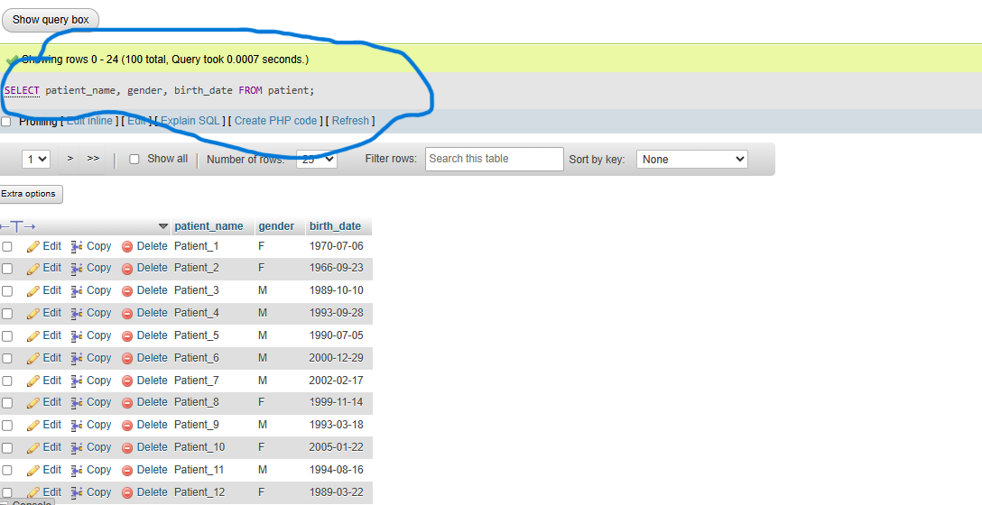
QUESTION 2 List all doctors and their specializations. 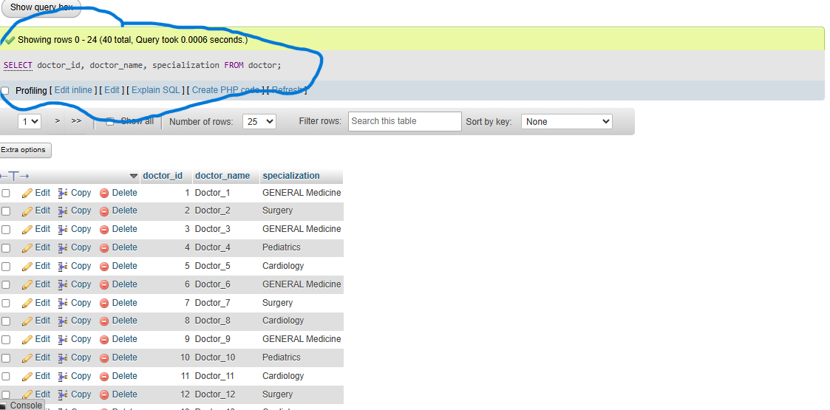
QUESTION3 Show all visits that occurred in the last 30 days.
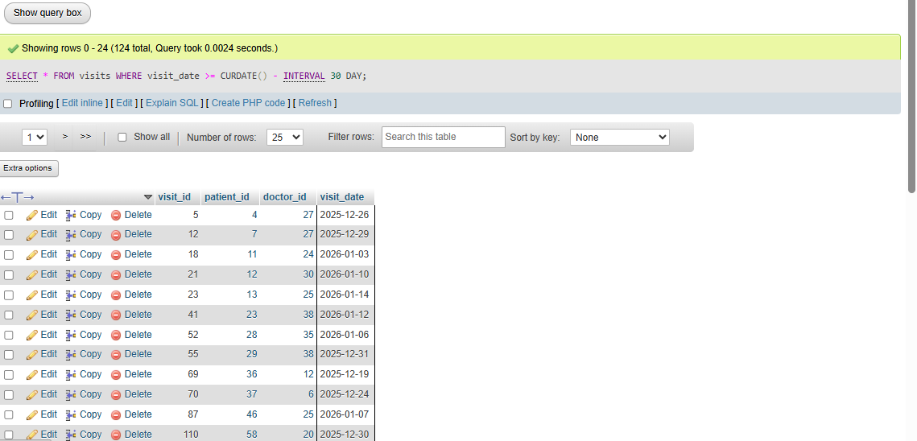
QUESTION 4 Display all visits handled by a specific doctor (e.g., Doctor_5).
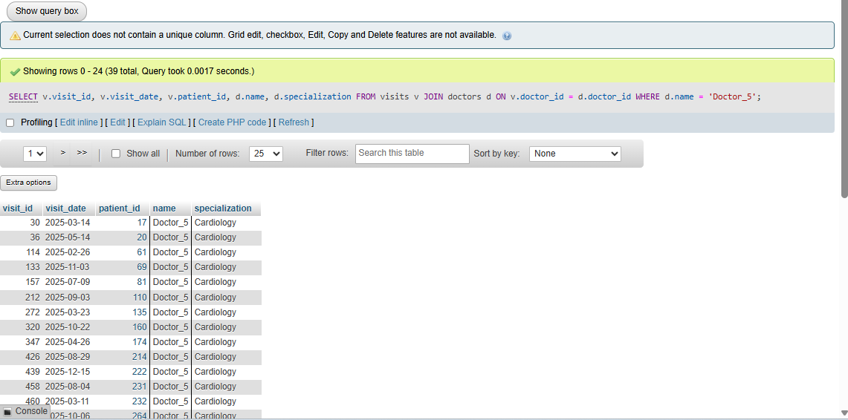
Question5 Count the total number of patients in the hospital. 5 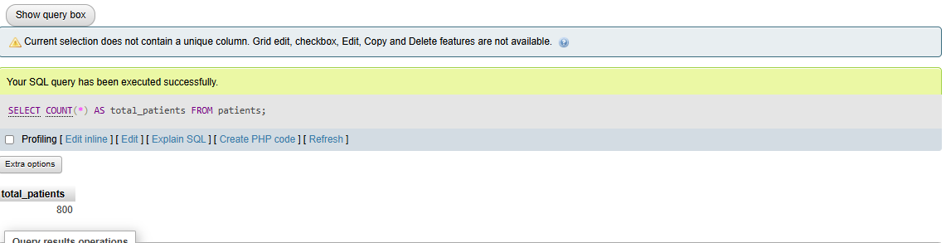
SECTION B: Display patient name, doctor name, and visit date for every visit.
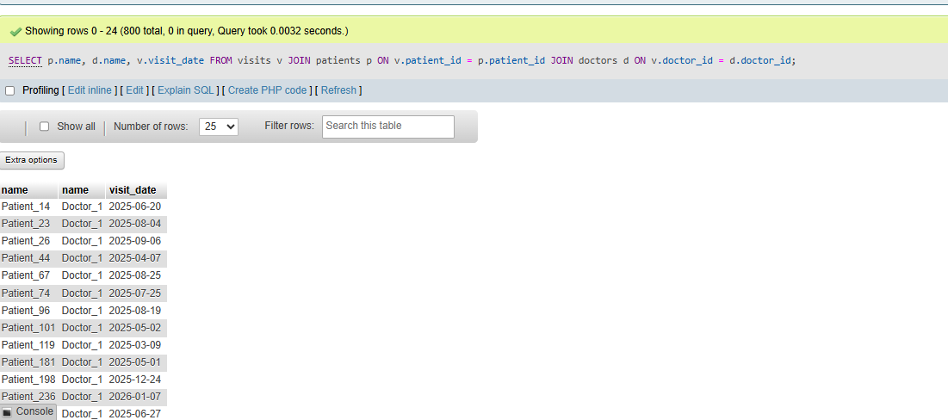
Question 6 Show a list of patients and the doctors who treated them.
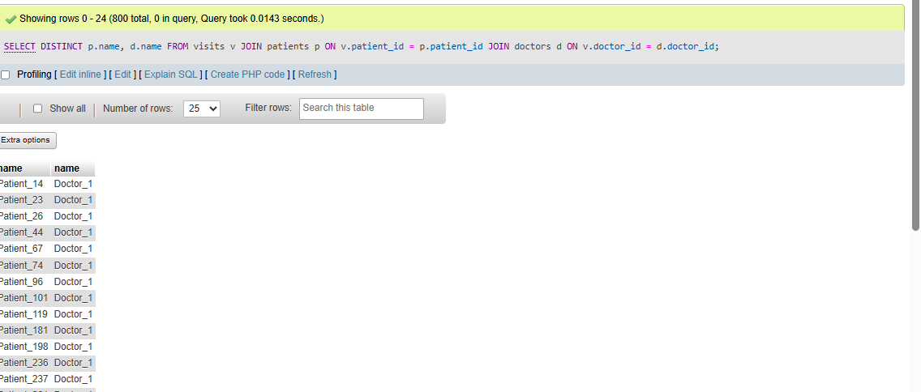
Question7 Display visit details, including treatment cost. 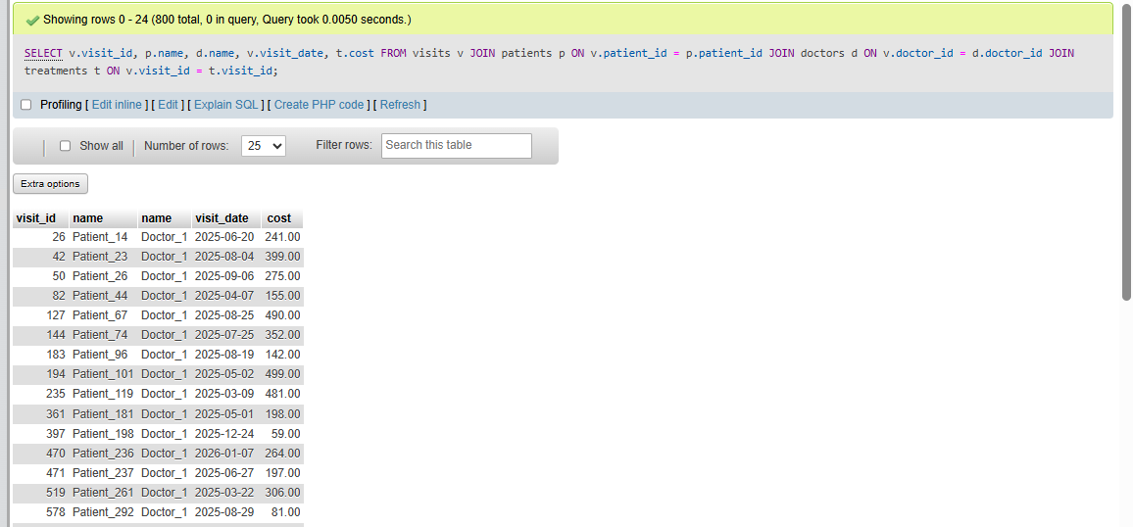
Question8 List all visits where the treatment cost is greater than 300.QU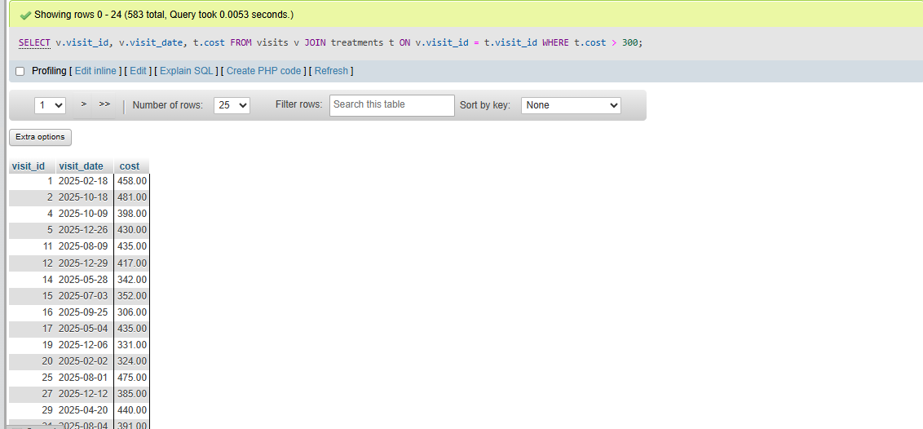
Question 9 Show all patients who were treated by doctors in cardiology. 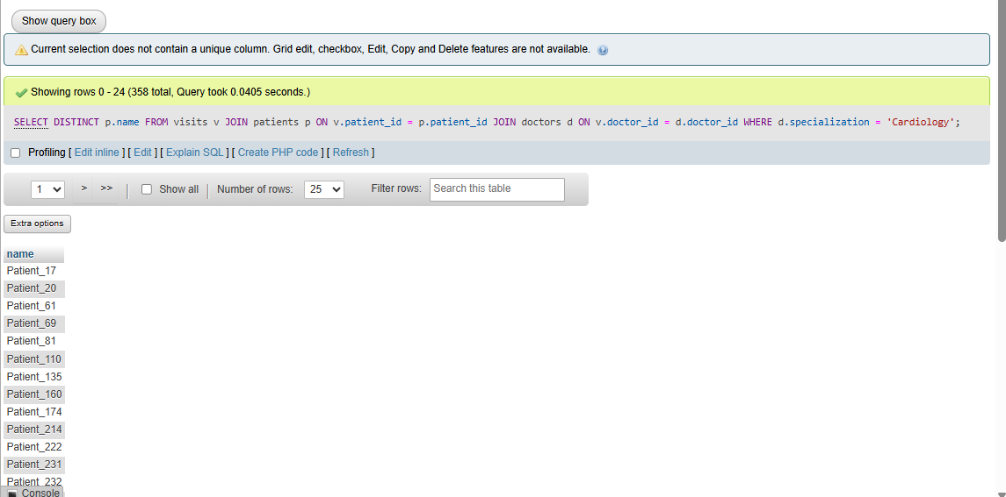
Quetsion10 Show all patients who were treated by doctors in cardiology.
SECTION C:
QUESTION:11 Count the number of visits handled by each doctor 11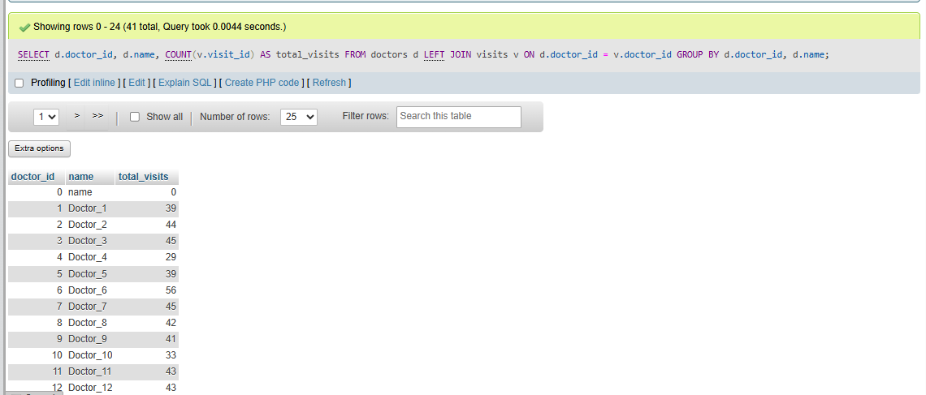
Question12 List doctors who handled more than 50 visits.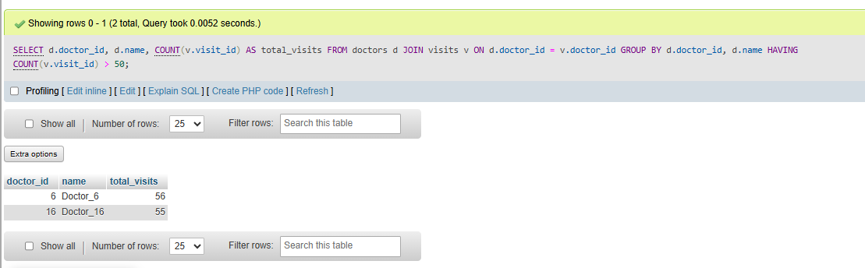
Question13 Find the doctor with the highest number of visits. 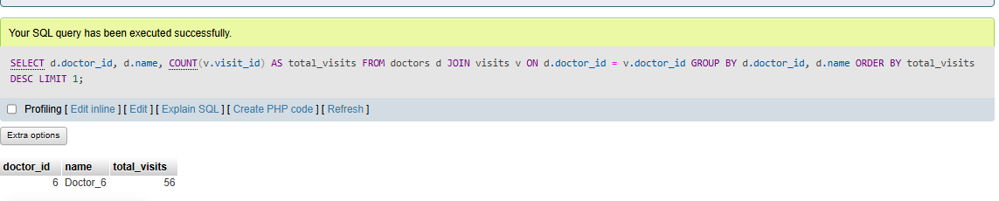
Question 14 Calculate the average number of visits per doctor.
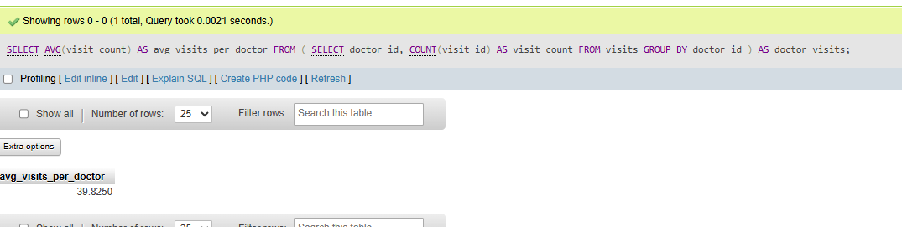
Question 15 Rank doctors by number of patients treated (MySQL 8+).